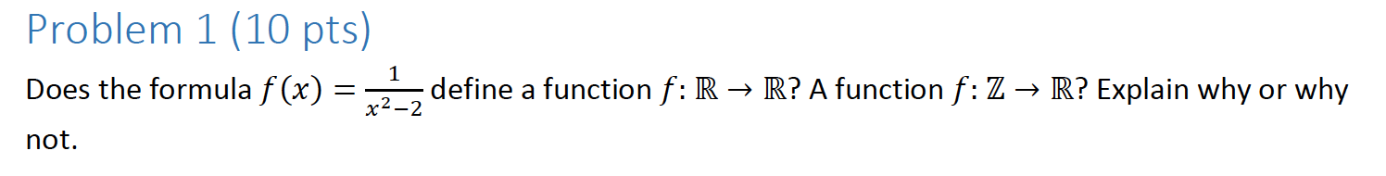

For all real numbers:

No, 1/x2-2 does not define a function for all real numbers, because if you plug in either √2 or -√2, you get 1 / 0 which is undefined.

From all integers to R:

Yes, 1/x2-2 is a function because for every x, there is exactly one unique y as the result, and there are no integer values for x that cannot be plugged in to get an answer.

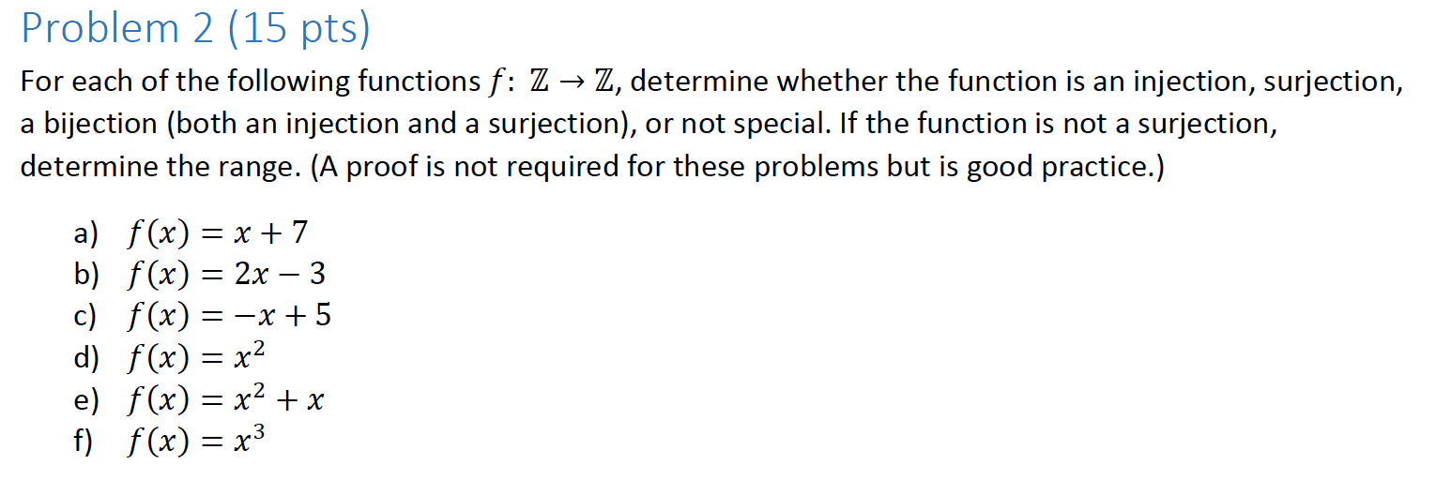

1. F(x) = x + 7

This is a function because every x has exactly one unique y.

This function is both injective and surjective because each integer y can be mapped to, and each integer x is mapped from, and each x produces exactly one unique value of y.

Proof:

Let f(x1) = f(x2).

X1 + 7 = X2 + 7

Through Algebra, we get that X1 must equal X2! Thus, by definition, the function is injective.

Y = x + 7

I must find an x such that f(x) = y. Working backwards, I know that such a y exists at x = y-7.

If I plug in this x, I get f(y-7) = (y-7)+7 = y.

Thus, by definition, this function is surjective.

And since the function is both injective and surjective, it is, by definition, bijective.

1. F(x) = 2x+3

This is a function because every x has exactly one unique y.

The function is injective because every value of x can be plugged in, or mapped to.

Proof:

Let F(x1) = F(x2)

2x1 + 3 = 2x2 + 3

Through algebra, x1 = x2.

The function is not surjective because not every value of y can be mapped to. The value 0, for example, would require x to be a number that is not an integer.

Thus, this function is only injective.

c). f(x) = -x + 5

This is a function because every x has exactly one unique y.

This function is injective because each integer value of x can be plugged in, and mapped from.

Proof:

Let f(x1) = f(x2)

- x1 + 5 = x2 + 5

Through algebra, x1 = x2.

Thus, the function is injective.

The function is surjective because each integer value of y can be reached, or mapped to.

Plug in x = -y+5:

F(-y+5) = -(-y+5)+5 = y

Thus, the function is bijective.

d). f(x) = x2 from Z to Z.

This function is not injective because there are two values that lead to the same y. 2 and -2 for example.

Proof:

Let f(x1) = f(x2)

x12 = x22.

x12 –x22 = 0

(x1 + x2)( x1 – x2) = 0.

x1 = x2 or x1 = - x2.

The function is not surjective because not every y value can be mapped to. For example, it is impossible to plug in an integer for x and get a y value of 3.

Proof:

The only way to get f(x) = y is if x = √y, and that is not an integer.

Therefore, this function is neither injective nor surjective.

e). f(x) = x2 + x

This function is not injective because you can plug in either x = 0 or x = -1 to get y = 0. Therefore, there are two values that lead to the same y.

This function is not surjective because not every value of y can be mapped to. For example, it is not possible to get a value of 1 for this function, plugging in an integer value of x. The proof for this is similar to the proof above.

f). f(x) = x3

This function is injective because there are no values of x that can be plugged in to get the same value of y, thus each connection is unique.

This function is not surjective because not every value of y can be mapped to. For example, it is not possible to get a value of 2 for this function, plugging in an integer value of x. The proof for this is similar to the proofs above.

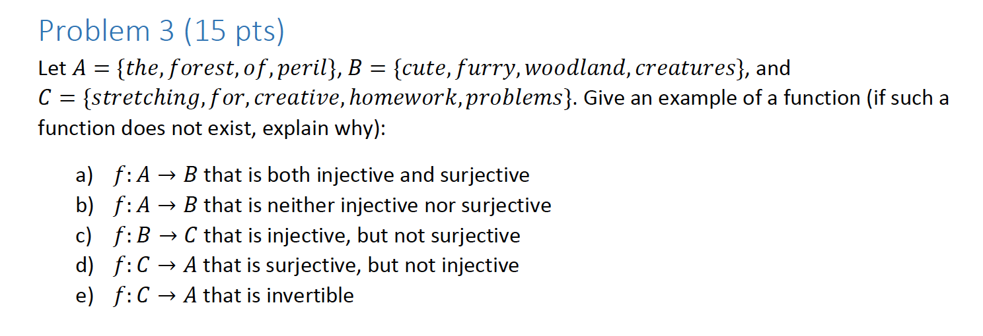

1. F: A → B that’s both injective and surjective:

{(the, cute), (forest, furry), (of, woodland), (peril, creatures)}

1. F: A → B that’s neither injective and surjective:

{(the, cute), (forest, furry), (of, woodland)}

1. F: B → C that’s injective but not surjective:

{(cute, stretching), (furry, for), (woodland, creative), (creatures, homework)}

1. F: C → A that’s surjective but not injective:

{(stretching, the), (for, forest), (creative, of), (homework, peril)}

1. F: C → A that’s invertible:

A function that is invertible from C to A does not exist because the cardinality of C is greater than the cardinality of A, therefore it is impossible to make from C to A without reusing terms, and it is impossible to make sure the connections are both injective and surjective.

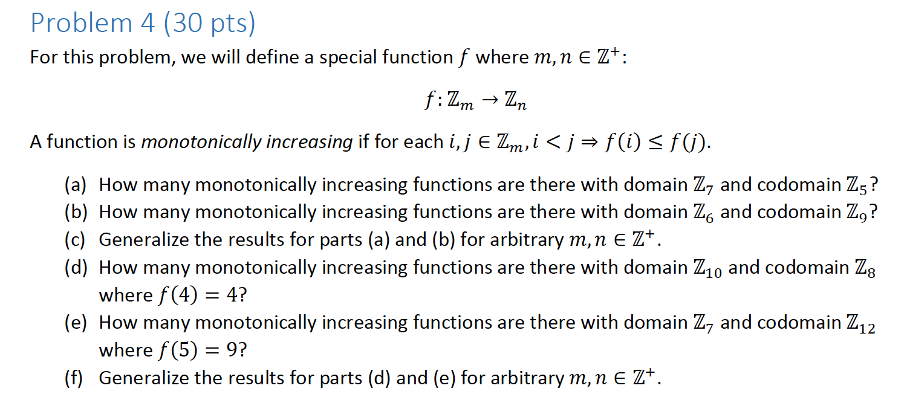

1. The domain Z7 is the set {1,2,3,4,5,6,7}. The domain Z5 is the set {1,2,3,4,5}.

That means that each element of the domain will map to an element of the codomain.

When you map these numbers, you find that there are seven dividers in between each of the 12 numbers.

Thus, we have 1 _ 2 _ 3 _ 4 _ 5 _ 6 _ 7 _ 1_2_3_4_5

And we need to choose seven dividers.

So that’s (117) combinations.

1. The domain Z6 is the set {1,2,3,4,5,6} and the domain Z9 is the set {1,2,3,4,5,6,7,8,9}.

Each element of the first maps to the second. When you map these two numbers, you will find that there are 6 dividers in between each of the numbers.

1 _ 2 _ 3 _ 4 _ 5 _ 6 _ 7 _ 8 _ 9 _ 1 _ 2 _ 3 _ 4 _ 5 _ 6

So that’s (146) ways.

1. For any arbitrary m and n, the y, the amount of monotonically increasing functions, = **(m+n-1m)**.
2. The domain Z10 represents the set {1,2,3,4,5,6,7,8,9,10} and Z8 represents the set {1,2,3,4,5,6,7,8}.

Since f(4) = 4, you only have one choice for 4, so we can calculate the number of possibilities of 1 through 3 and 3 through 10.

So if you take away 4 and 4, the new sets become:

set {1,2,3,5,6,7,8,9,10} and set {1,2,3, 4, 5,6,7,8}.

Thus we have (169) ways.

1. F(5) = 9, and domain Z7 = {1,2,3,4,5,6,7} and codomain Z12 = {1,2,3,4,5,6,7,8,9,10,11,12}.

Since we know f(5), we can simply remove 5 from the Z7 set since there is only one way to use 5.

So the sets become:

Z7 = {1,2,3,4,6,7} and Z12 = {1,2,3,4,5,6,7,8,9,10,11,12}

Which is (176) ways.

Let H represent the number of known values for the function.

For any arbitrary m and n, the y, the amount of monotonically increasing functions, = (m + n – 1 - H m) and any element that is known is removed from the domain.

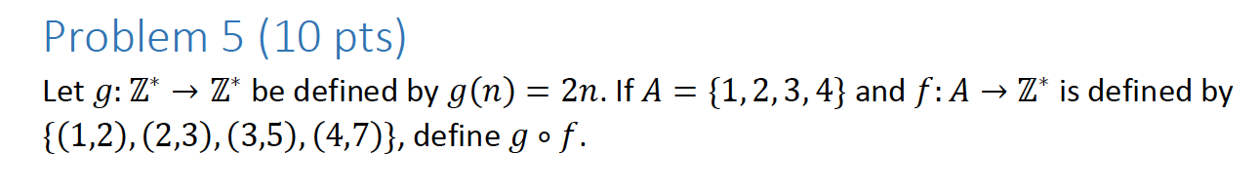

Since A = {1, 2, 3, 4}, and A → Z = {(1, 2), (2, 3), (3, 5), (4, 7)}, and I know the function g = 2n.

I can plug in f into n.

G(n) = {(1, 2), (2, 3), (3, 5), (4, 7)} * 2

G(n) = {(2, 4), (4, 6), (6, 10), (8, 14)}

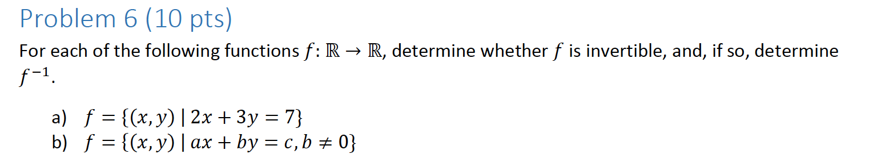

1. 2x + 3y = 7

2x – 7 = 3y

Show surjective:

Let f(x) = y for some arbitrary y. Then, y = 2x-7 / 3 which is an element of all real numbers, and x = 3y+7 / 2, which is also an element of all real numbers.

Show injective.

Let f(x1, y1) = f(x2, y2)

Then 2x1 + 3y1 = 7 and 2x2 + 3y2 = 7

Through algebra, x1 must equal x2 and y1 must equal y2!

Since any value of x can be plugged in so long as there is a corresponding y, the function is injective.

Since any value of y can be plugged in so long as there is a corresponding x, the function is surjective.

Thus, the function is injective, and thus invertible.

Normally, f(x) = 2x – 7 / 3. To get the inverse, we just need to replace the x’s with y’s and vice versa.

2y + 3x = 7

**f-1(x, y) = 7 – 3x / 2.**

1. Ax + by = c, b is not equal to 0.

Show surjective:

Let f(x) = y for some arbitrary y. Then, y = c – Ax / b, which is an element of all real numbers, and x = c – by / A.

But since the function is undefined when A = 0, the function cannot be surjective.

Thus, the function is not bijective, and the function is not invertible.

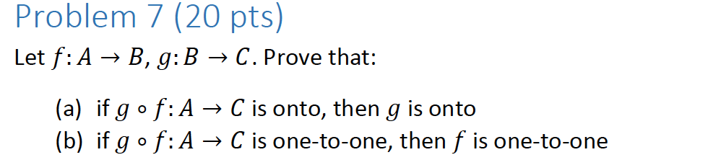

1. Proof:

Onto means surjective, by definition.

Let b be an arbitrary element of B.

Since g ° f is surjective, that means ∃A∃C such that g(f(A, C)) = C.

If you substitute a value for f(A, C), let’s name it P, then you get that g(P) = C.

Thus, g must be surjective.

If this proof wasn’t formal enough, please look at the proof by contradiction below.

Proof by Contradiction:

g ° f: A → C is surjective.

g is not surjective.

Let b be an arbitrary element of B. Since g is not surjective, ∀aεA (g(A) ≠ B).

Based on our premise, we know that g(f(A)) = C for some value of A.

Since g is not surjective, anything we plug in for g(B) cannot be surjective either, because it is being plugged into B.

Thus, g(f(A)) ≠ B. But that’s a contradiction!

Thus, if g ° f: A → C is onto, g must be onto.

Proof by Contradiction:

F is not surjective.

If g ° f is injective, g(f(x1)) = g(f(x2)). Since f is not injective, that means that f(x1) is not equal to f(x2). Since they are not equal, plugging them into the same function will also not be equal, so g(f(x1)) is not equal to g(f(x2)). But that’s a contradiction, since we know g(f(x1)) = g(f(x2)). Thus, if g ° f: A → C is one-to-one, then f is one-to-one.

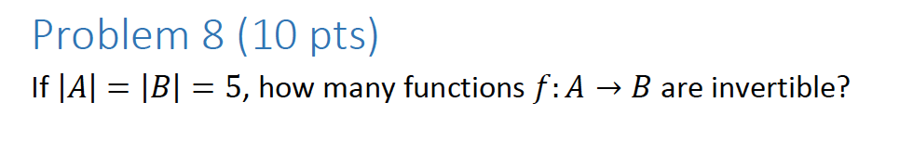

There is exactly one function that is invertible, because A and B have the same cardinality, and if you match each individual element of A to each individual element of B, without reusing elements, you get a function that is bijective and thus invertible.

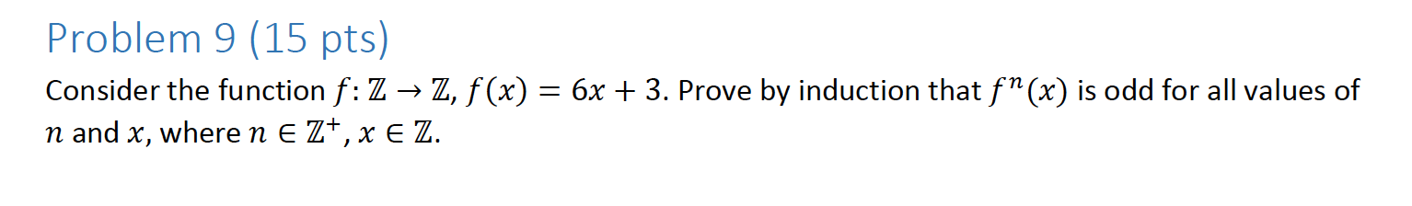

Base Case:

X = 6x + 3

Y = 6(6x+3) + 3

Y = 36x + 21

Y = 2(18x + 10) + 1

Therefore, x = 6x + 3 is odd.

This works for our base case.

I.H: Assume that 6k + 3 is odd for all values of k.

I.S.: Prove that 6(k+1) + 3 is odd for all values of k, k ε Z. where k = 6k+3

Y = 6(6(k+1)+3)+3

Y = 6(6k+9) + 3

Y = 36k + 57

Y = (6k + 3) + (6k+3) + (6k+3) +(6k+3) +(6k+3) +(6k+3) + 39

Since 39 is odd, and we know an odd number plus an odd plus an odd equals an even, and we have seven odds being added together, we get to the point where we have

Even + even + even + odd

And we know that two evens added together equal an even, so we get

Even + odd

And even + odd must equal an odd number.